**Додаткові завдання**

**№1**

#include <fstream>

#include <iostream>

#include <string>

#include <Windows.h>

// #define If_check

using namespace std;

ofstream fout;

ifstream fin;

string outpath = "output.txt";

string inpath = "input.txt";

void output_check(double n);

void input_reading(string filename);

void input_reading(string filename)

{

double num;

fin.open(filename);

if (!fin.is_open())

{

#ifdef If_check

cout << "Error" << std::endl;

#endif If_check

}

else

{

#ifdef If_check

cout << "Is open" << std::endl;

#endif If_check

while (!fin.eof())

{

fin >> num;

cout << "n = " << num;

}

}

fin.close();

num = pow(2,num);

output_check(num);

}

void output_check(double n)

{

string text = "Result = ";

fout.open(outpath);

fout << text << n;

fout.close();

system("start output.txt");

}

int main()

{

SetConsoleOutputCP(1251);

SetConsoleCP(1251);

input_reading(inpath);

return 0;

}

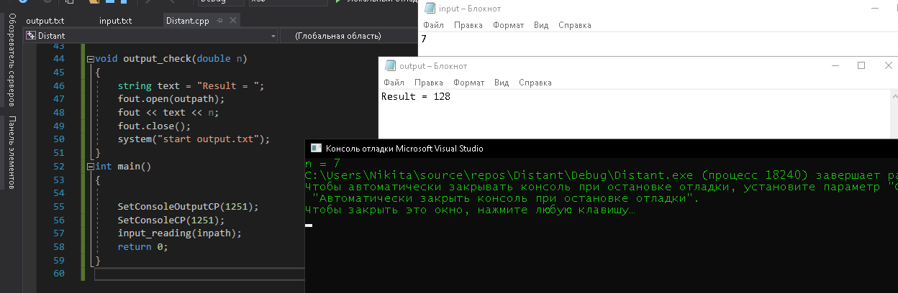

**№2**

#include <iostream>

#include <algorithm>

#include <vector>

#include <Windows.h>

// #define If_check

using namespace std;

bool check(int a, int b)

{

return b - a > 1;

}

void random_gen(vector <int> vec)

{

for (int i = 0; i < 5; ++i)

{

vec.push_back(rand() % 20 + 1);

}

sort(vec.begin(), vec.end(), [](int a, int b) {

return a < b;

});

for (auto &i : vec)

{

cout << i << " ";

}

cout << endl;

cout << "Минимальное отсутсвующее - ";

for (int i = 0; i < 2; ++i)

{

if (check(vec[i], vec[i + 1]) == true)

cout << vec[i] + 1 << " ";

}

}

int main()

{

SetConsoleOutputCP(1251);

SetConsoleCP(1251);

vector <int> vector;

cout << "Последовательность натуральных чисел: ";

random_gen(vector);

system("pause>null");

return 0;

}

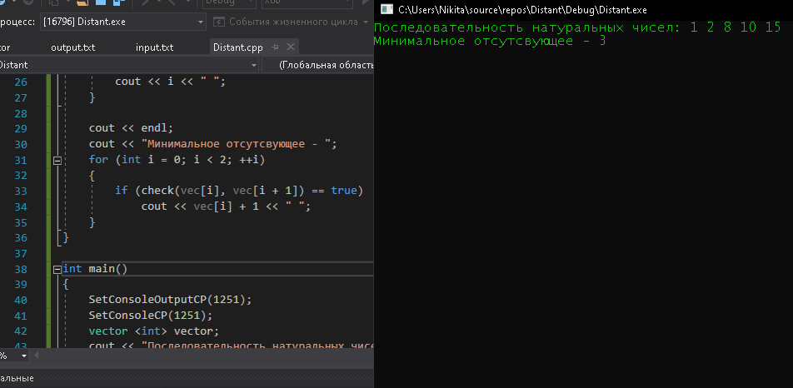

**№3**

#include <fstream>

#include <iostream>

#include <string>

#include <vector>

#include <Windows.h>

// #define If_check

using namespace std;

ifstream fin;

string inpath = "input.txt";

void input_reading(string filename)

{

string text;

vector <string> vec;

string res;

fin.open(filename);

if (!fin.is_open())

{

#ifdef If_check

cout << "Error" << std::endl;

#endif If_check

}

else

{

#ifdef If_check

cout << "Is open" << std::endl;

#endif If_check

while (getline(fin, text))

{

vec.push_back(text);

}

int k = 0;

for (int i = 0; i < vec.size(); ++i)

{

for (int c = 0; c < vec.size(); ++c)

{

if (vec[c] == vec[i])

{

++k;

}

}

if (k == 1)

{

cout << "Уникальная строка - " << vec[i] << endl;

k = 0;

}

else k = 0;

}

}

fin.close();

}

int main()

{

SetConsoleOutputCP(1251);

SetConsoleCP(1251);

input_reading(inpath);

system("pause>null");

return 0;

}

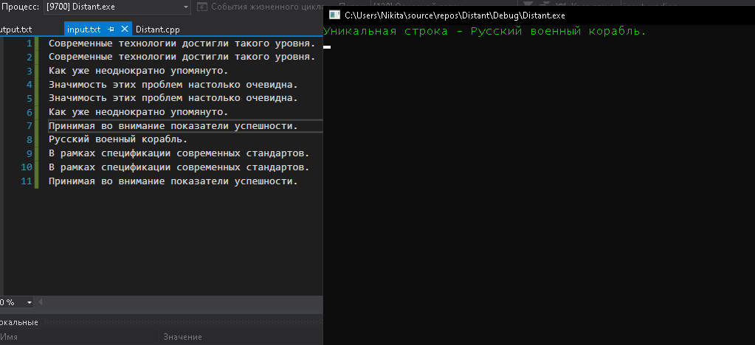

**№4**

#include <iostream>

#include <vector>

#include <iterator>

#include <algorithm>

#include <Windows.h>

// #define If_check

using namespace std;

void counter(int N)

{

vector<int> numbers = {0,1,2,3,4,5,6,7,8,9};

vector<int> numbers_primal = { 0,1,2,3,4,5,6,7,8,9 };

int start_num = N;

int n = N;

int count = 0;

while (n) {

n /= 10;

count++;

}

int k = 0;

for (int i = 0; i < count; ++i)

{

n = N % 10;

N = N / 10;

for (int c = 0; c < numbers.size(); c++)

{

if (n == numbers[c])

{

k++;

numbers[c] = -1;

}

}

}

numbers = numbers_primal;

if (k > 2)

{

start_num++;

counter(start_num); //рекурсия

}

else cout << "Ближайшее двоякое число - " << start_num << endl;

}

int main()

{

int num;

SetConsoleOutputCP(1251);

SetConsoleCP(1251);

cout << "Введите натуральное число: ";

cin >> num;

counter(num);

system("pause>null");

return 0;

}

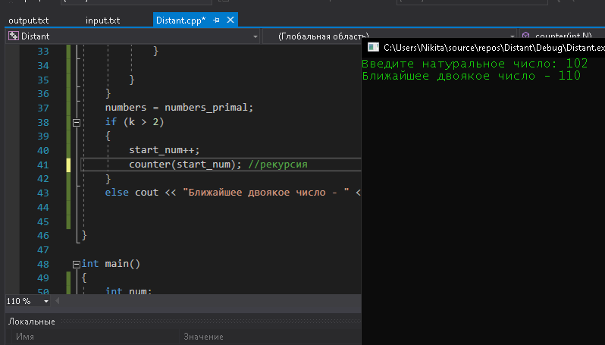

**№5**

#include <iostream>

#include <Windows.h>

// #define If_check

using namespace std;

bool Num(int n)

{

for (int k = 2; k <= n - 1; ++k)

{

int temp = n % k;

if (temp == 1)

{

if (k == n - 1) return false;

}

else if (temp == 0) return true;

}

}

void simple_num(int N)

{

int temp = 0;

for (int k = 2; k <= N; ++k)

{

if (N % k == 1)

{

k++;

}

if (N % k == 0)

{

temp = N / k;

cout << k;

if (temp != 1)cout << "*";

simple_num(temp);

}

if (temp == 1) exit(0);

}

}

int main()

{

int num, c = 0;

SetConsoleOutputCP(1251);

SetConsoleCP(1251);

while (c != 2)

{

c++;

cout << "Введите натуральное число: ";

cin >> num;

bool res = Num(num);

if (res == true)

{

cout << "Разложение на множители:" << endl;

simple_num(num);

}

else cout << "Число и так простое" << endl;

}

system("pause>null");

return 0;

}

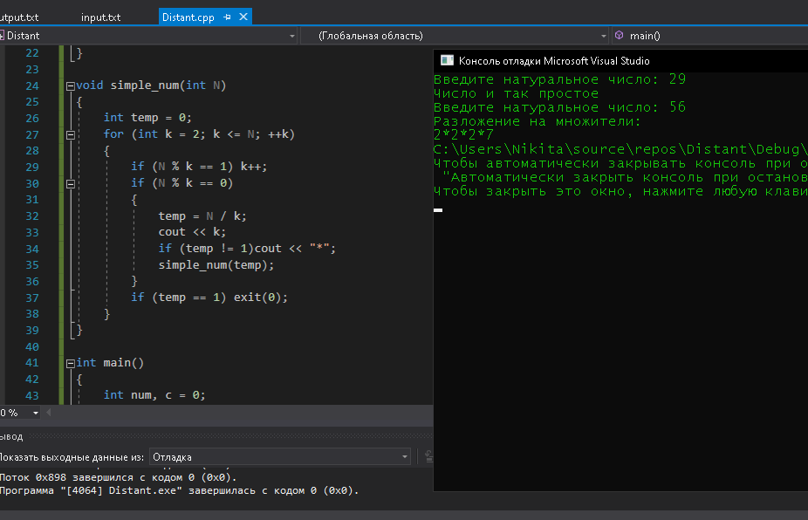

**№6**

#include <iostream>

#include <Windows.h>

// #define If_check

using namespace std;

bool Num(int n)

{

int x = 0;

if (n < 4) return false;

for (int k = 2; k <= n - 1; ++k)

{

int temp = n % k;

if (temp == 1)

{

if (k == n-1) return false;

}

else if (temp == 0) return true;

}

}

int main()

{

int a = 0, b = 0;

SetConsoleOutputCP(1251);

SetConsoleCP(1251);

cout << "Введите 2 числа для диапазона:" << endl;

cin >> a >> b;

while (a != b)

{

bool res = Num(a);

if (res == false) cout << a << " ";

a++;

}

system("pause>null");

return 0;

}

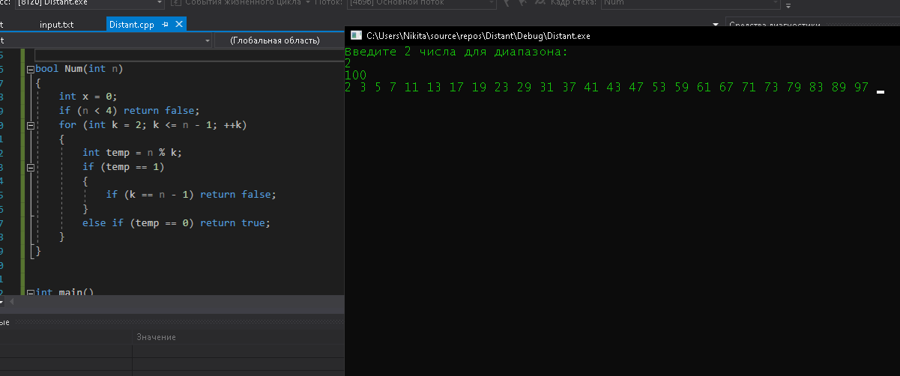

**№7**

#include <iostream>

#include <Windows.h>

using namespace std;

int main()

{

int a = 3, b = 5;

SetConsoleOutputCP(1251);

SetConsoleCP(1251);

cout << " a = " << a << " b = " << b << endl;

a = a * b; // a = 15

b = a / b; // b = 3

a = a / b; // a = 5

cout << "New: " << endl;

cout << " a = " << a << " b = " << b << endl;

system("pause>null");

return 0;

}

